Probability distribution II:
Normal distribution, z-scores,
Confidence Interval I
Probability distribution topic will be divided into several lectures
(this is the second lecture)
Recall from last time….
- μ (reads as “Myu”) denotes Mean
- σ (reads as “Sigma”) denotes Standard Deviation
Let us introduce z (also called z-score), a number of SDs away from the mean.
- Consider the next slide. Important: z=1 corresponds to 1 σ (1 SD) away from the mean, z=2 corresponds to 2 σ (2 SD) away from the mean, etc.
Normal distribution with number of SDs away from the mean shown
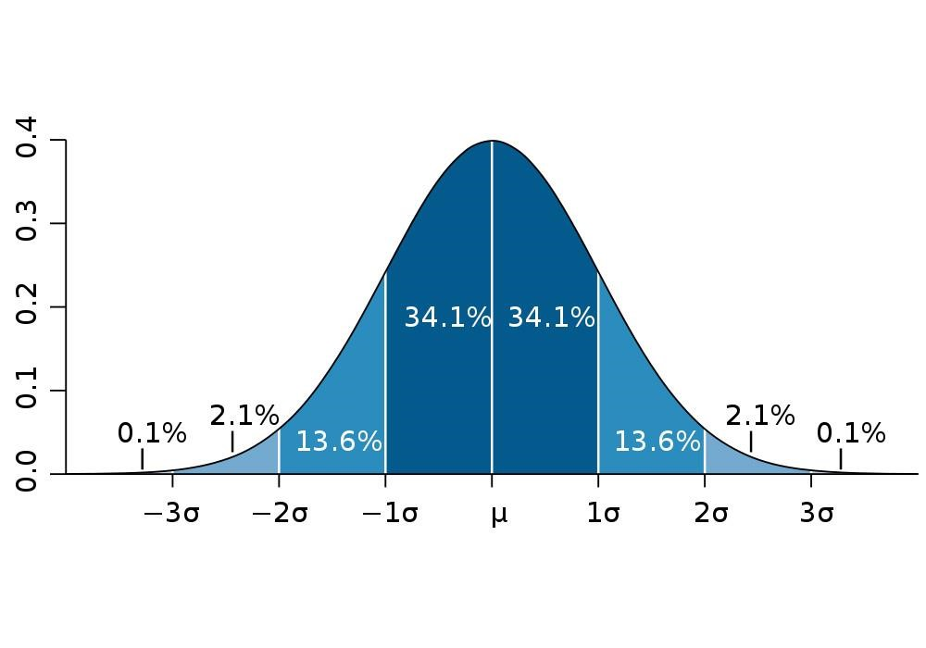

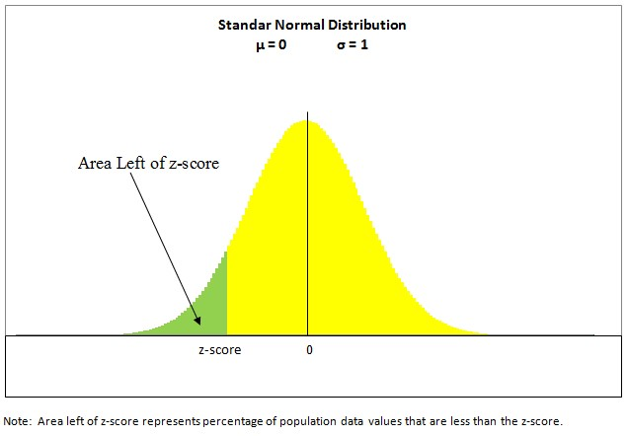
Standard Normal Distribution
• Standard Normal Distribution is a Normal
Distribution, where Mean =0 and SD=1

Distribution tails
- In ANY normal distribution, if we move 1.96 SD from the mean (z=1.96) , then area under the curve α (pronounced alpha) to the right from z=1.96 is 0.025 (or 2.5%);
Equivalently, area under the curve α to the left from z= -1.96 is 0.025 (2.5%).
- Note that α is also the probability of having values to the right of z and/or to the left of z.
- It is a common practice, when we describe 2 tails, to denote area to the right of z as α/2 and area to the left of –z as α/2 , thus for z=1.96, α/2 =0.025 and for z=1.96, α/2 =0.025 ; therefore, α/2 + α/2 is 0.05
- Area to the right from the threshold z is called right tail and area to the left from the threshold –z is called left tail.

Normal distribution
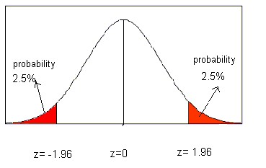
Note, these are “z” values (number of SDs away from the Mean, NOT the actual variable values
- The area between two red tails is enclosed my Mean ± (1.96*SD).
- Thus area in between z=-1.96 and z=1.96 is
1-(α/2 + α/2)= 1- α = 1-(0.025+0.025)= 1 - 0.05 = 0.95 or alternatively, 100%-(2.5%+2.5%)=95%
- This means that 95% of the distribution values fall in this interval between z=-1.96 and z=1.96. This interval is called 95% confidence interval.
- Or we can say that 95% of patients fall into this interval
- In fact, the notion of confidence interval can be applied to any kind of distribution – not only to normal distribution.

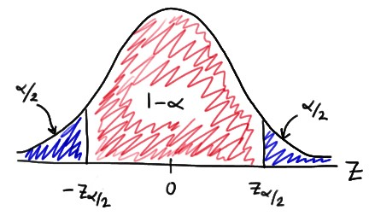
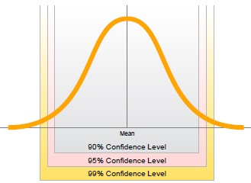

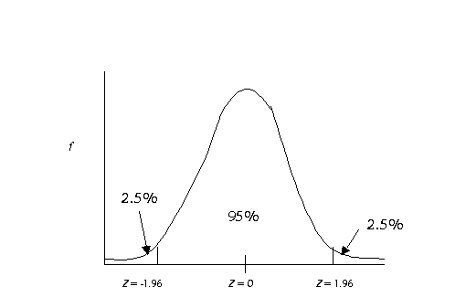
If we consider
two tails
…
These tails will capture values either significantly smaller or larger than the Mean (also called “different” from the Mean).

If we consider one tail …
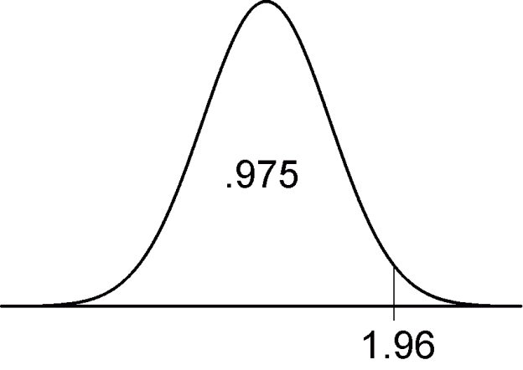
Z=
This right tail corresponds to values that are the significantly larger/greater than the Mean. (Same logic applies to the left tail).

Example 1
- Let us assume that the distribution of prostate volumes across some population is normal with Mean=35.46 ml and SD=16.35 ml. Enlarged prostates indicate abnormality and might be a sign of prostate cancer.
- How typical is the patient with prostate volume 59 ml?
Note that here we assume that a patient that falls into the right tail (α=2.5%) of this distribution has abnormally large prostate volume (we do not care about small prostates here) – thus we do not need to consider left tail and consider right tail ONLY.
and that a patient that falls into the area corresponding to 100%-α
(area under the curve to the left of α) has normal prostate volume.
- Mean of the distribution μ= 35.46
- SD of the distribution σ=16.35
This is also written as N(Mean, SD^2)= N(35.46,16.35^2)
(you need to know this notation)
- Our patient has prostate volume x=59 ml
We need to calculate where our patient falls on this distribution.
If he is more than 1.96 SDs away from the Mean (to the right in this case), then he has abnormal prostate volume; and if he is less than 1.96 SDs away from the Mean – his prostate volume is within normal range.
- Let us calculate how many SDs away from the mean this patient is.
Z= (x - μ) / σ
= (59-35.46)/16.35
=1.44
Our answer: this patient has a large prostate (it is
1.44 SDs away from the mean), but not atypical one
(it is within 1.96 SDs away from the mean)
- We can also consult a table for Normal Distribution to draw conclusions (there is an example of such an abridged table on the next slide; however, a full table can be easily found online!!! – please find one!!!!)
- Using the table on the next slide, we can see that area under the curve to the right from z=1.44 (let us assume it is around 1.50 for simplicity) is α=0.067 (6.7%).
- Our answer: 6.7% of patients have prostate volume of at least 1.44 SDs greater than the mean (we used one tail values here because we are interested if the volume is “greater” than the mean); and our patient belongs to 6.7% of the patients with prostates at least that large.
- Note that if we were interested in the question if the volume is greater or less than the mean (i.e., sometimes is it called “different from the mean”), then we would use two-tailed approach

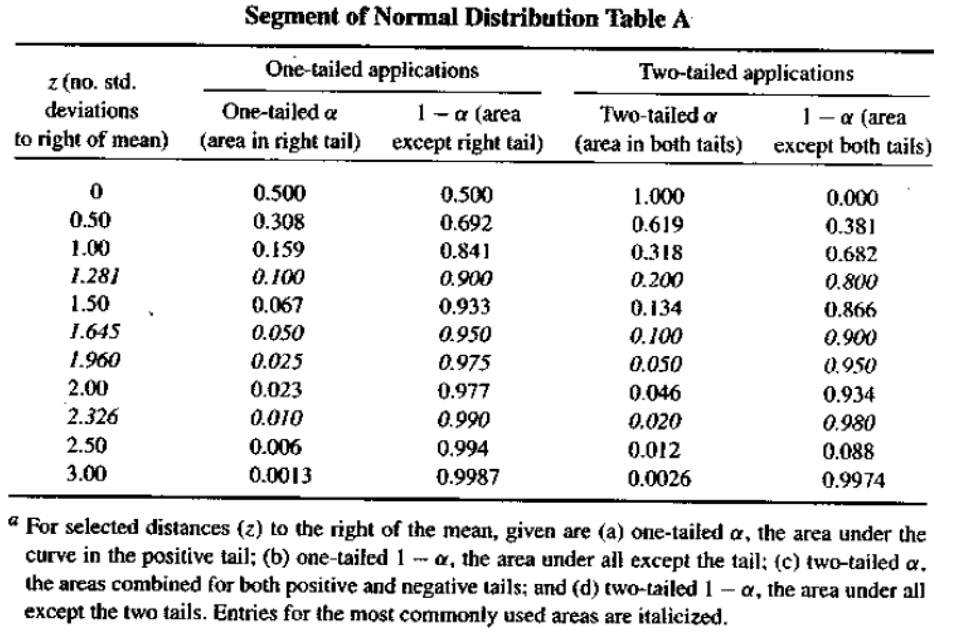

- Final answer: our patient is 1.44 SDs away from the mean (which is within normal range) and belongs to 6.7% of people with prostates at least that large (equivalently, 6.7% of patients have prostates at least that large).
- P.s. He might need a follow-up (as he is pretty close to 2.5%).

Example 2
- Let us assume that the distribution of prostate volumes across some population is normal with Mean=35.46 ml and SD=16.35. Enlarged prostates indicate abnormality and might be a sign of prostate cancer.
- How typical is the patient with prostate volume 83 ml?
Z= (x - μ) / σ
= (85-35.46)/16.35
=3.03
Our answer: It is definitely far away from the Mean, at 3.03 SDs, (expending much further to the right, even compared to z=1.96).
Let us look at the table now (assume z=3 for simplicity).

- α=0.0013, which is 0.13%.
- Our answer: Only 0.13% of patients have prostate so large. We conclude that a patient has atypical (too large) prostate volume.

PE1
- Let us assume that the distribution of prostate volumes across some population is normal with Mean=33 ml and SD=15 ml. Enlarged prostates indicate abnormality and might be a sign of prostate cancer.
- How typical are the patients with prostate volumes 30, 50, and 85 ml? (you might need to find a table for normal distribution online – be careful to use it correctly)

PE2
- Using data from Exercise 1: What is the % of patient population having at least that large prostates (for each of 3 prostate volumes indicated)? What is the % of patients having at most that large prostates (for each 3 prostate volumes indicated)?
- PE 4 is due Tue Oct 9th
- I will post solutions Wed Oct 10th
- Please review this lecture AND 2 x 2 table (i.e., FP,
FN, TP, TN), Specificity, Sensitivity, TPR, TNR, FPR,
FNR for the next lecture

